INSTALLATION
How to Install a WordPress Plugin
First thing you need to do is go to your WordPress admin area and click
on Plugins » Add New.
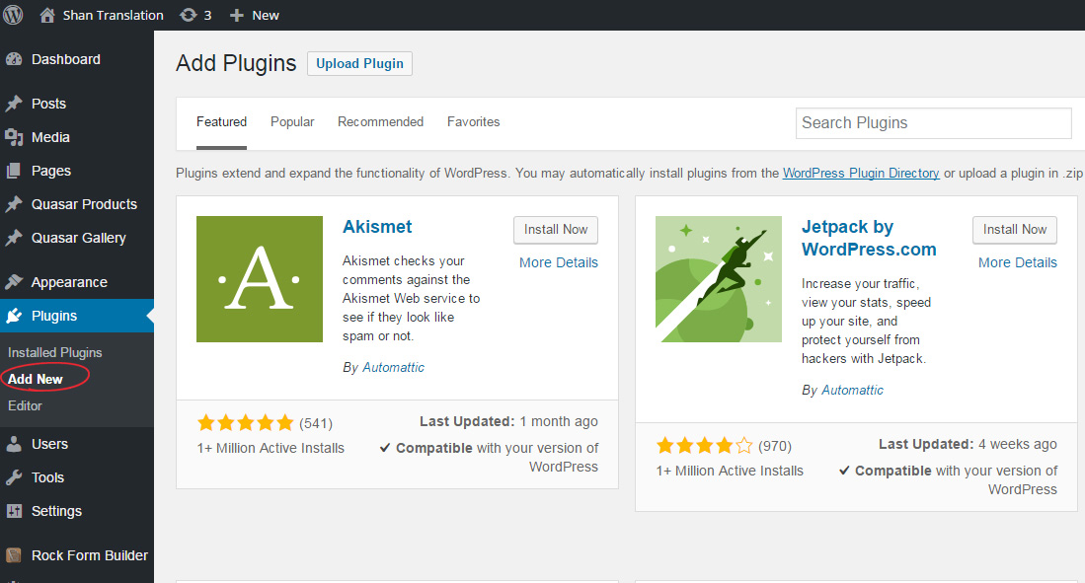

Option 1:
Search and Install
You will see a screen like the one shown in the screenshot below. Find the plugin by typing the plugin name ‘Sticky Floating Icons’.
Select the Sticky Floating Icons Plugin and click on ‘Install Now’ button.
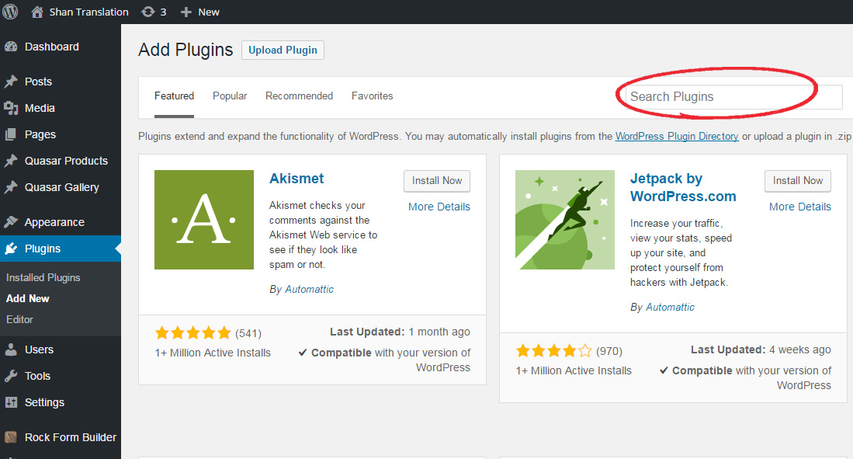

Option 2:
Install downloaded Plugin using the WordPress Admin Plugin Upload
First, you need to download the plugin from the link http://shantranslation.com/shan.zip (which will be a zip file). Next, you need to go to the WordPress admin area and visit Plugins » Add New.
Click on the ‘Upload Plugin’ button (as shown) on top of the page.
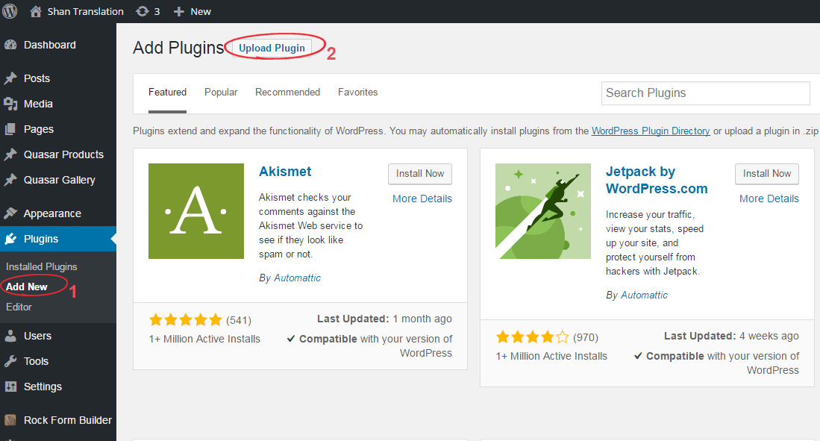

This will bring you to the plugin upload page. Here you need to click on the ‘Choose File’ button and select the plugin file you have downloaded earlier on your computer.
After you have selected the file, you need to click on the ‘Install Now’ button.
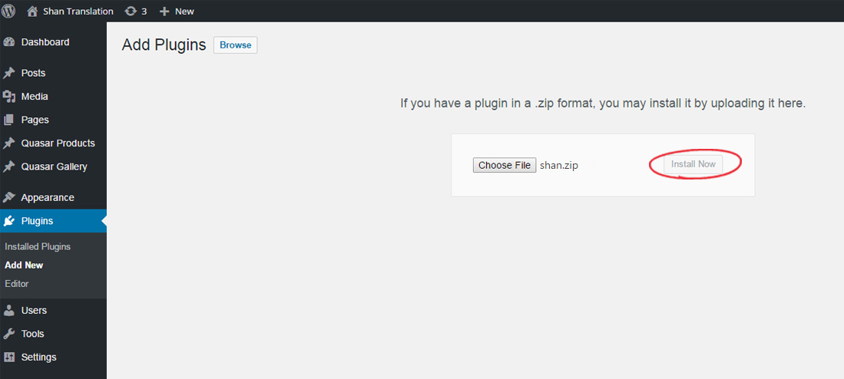

In both options:
WordPress will now upload the plugin file from your computer and install it for you. You will see a success message like this one after installation is finished.
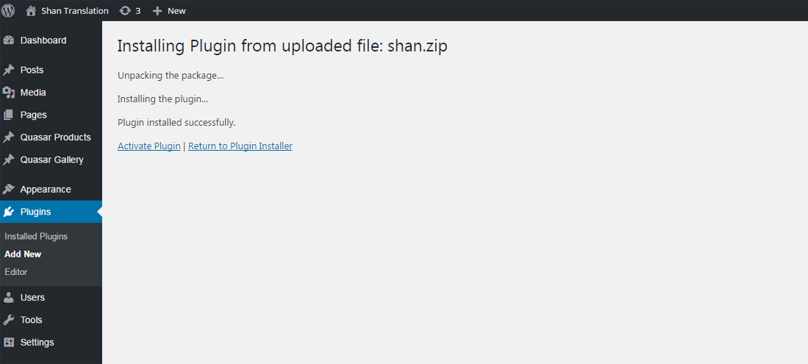
Once installed, you need to click on the ‘Activate Plugin’ link to start using the plugin.
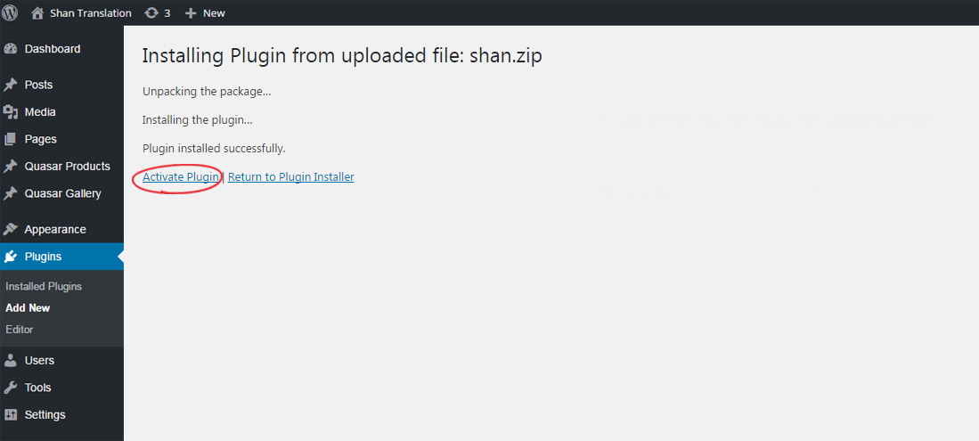

Congratulations!! In WordPress admin area you will now see the plugin Shan Sticky Slider (as seen below).
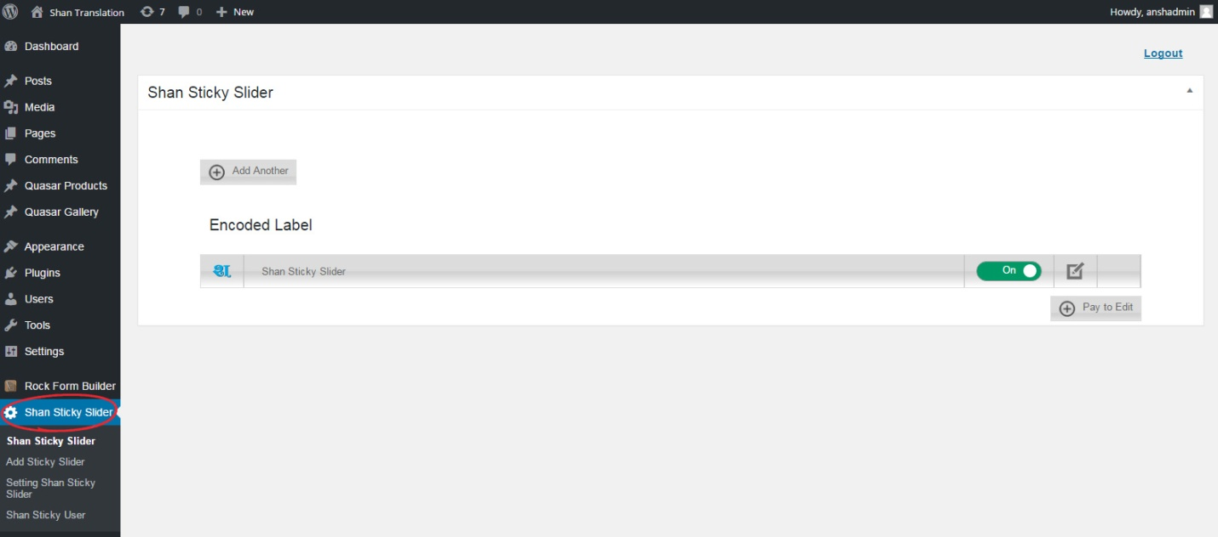
GETTING STARTED
To add an icon, go to the ‘Add Sticky Slider >> Add Another’
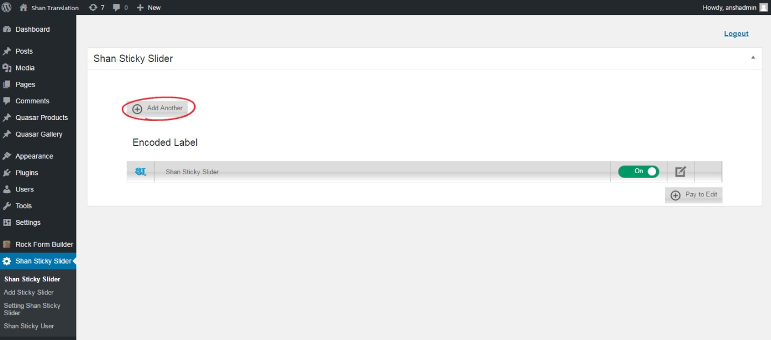

When you will click on ‘Add Another’, a Popup window will open
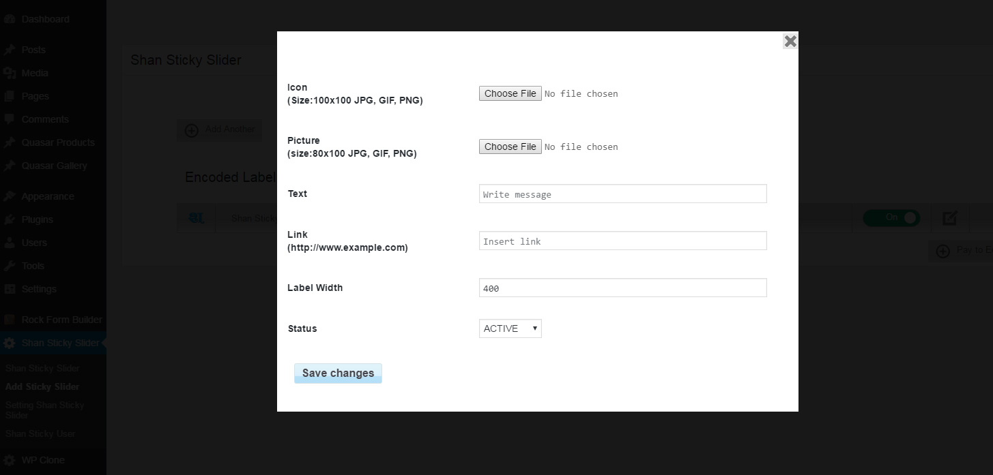
Popup will have following options:
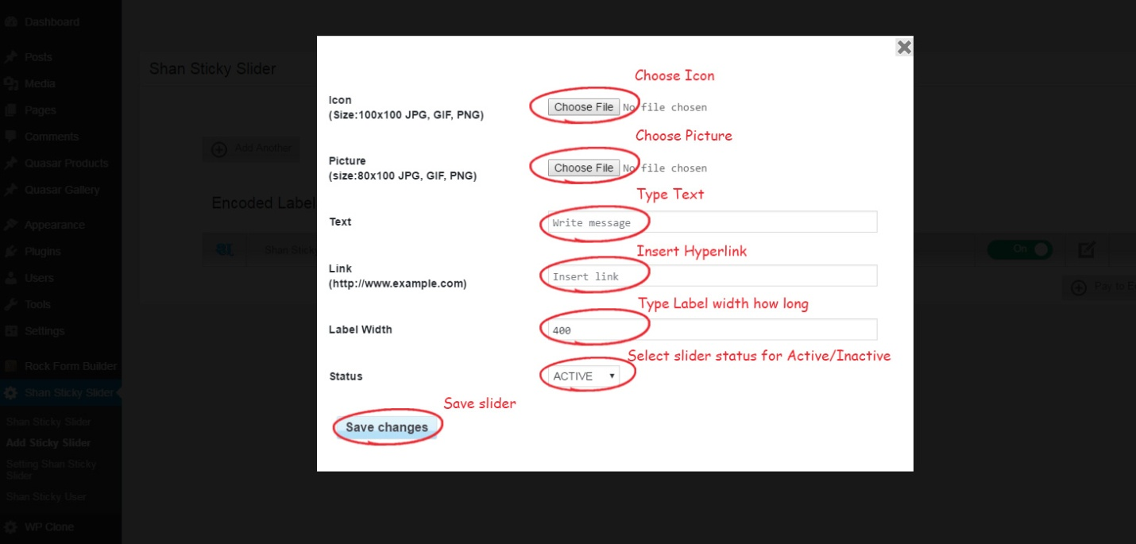

SETTING OF SSS
You can change font size, text color, background color, Icon Size and location. With the help of location you can set the slider on left or right side of your website.
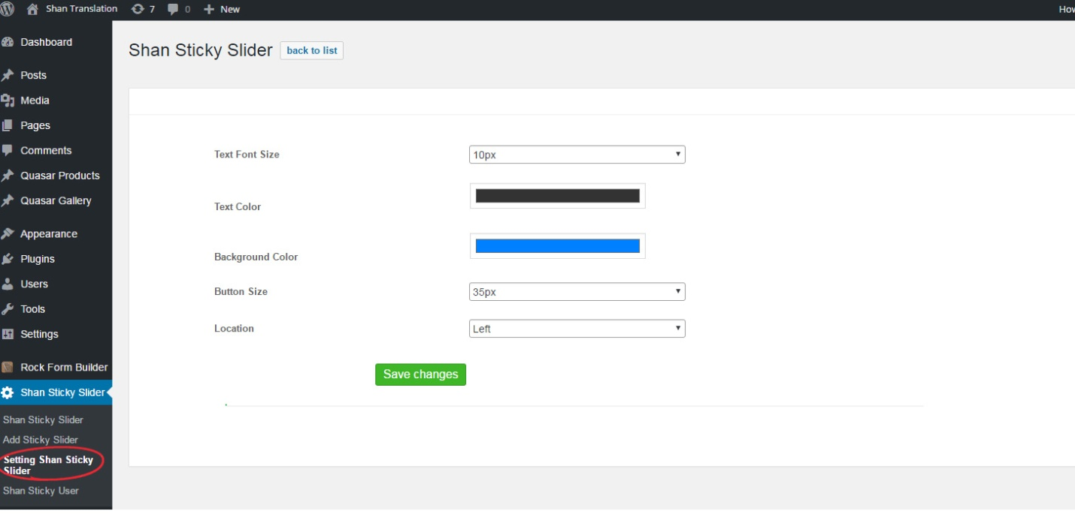

Setting of Shan Sticky User
Here the user can switch ON/ OFF for self
